

Contact: Odette Rodriguez FOR IMMEDIATE RELEASE
Tel: 212-334-6865
Email: odette@leelany.com

SHRIVAN and NARRESH: GYNOID SPRING/SUMMER 2011 COLLECTION
GYNOID: The Fantasy Future Woman

New York, NY- MARCH 17, 2011 India’s first and ONLY luxury swim wear brand SHRIVAN NARRESH has launched its new collection: GYNOID SS11. Inspired by the modern woman, GYNOID reveals the SHRIVAN and NARRESH futuristic fantasy woman. The collection celebrates this woman with innovative, futuristic, geometric shapes dominated by a color palette of coral, sea green & turquoise combined with somber mauves, lavender and nudes.

GYNOID incorporates soft cotton jersey, lycra, and polyurethane foam using a mix of vibrant colors. Stitch-free and handcrafted swimwear is the unique signature style of SHRIVAN NARRESH that is bold, confident and sophisticated. The maillots and bandeau bikinis with flawless lines and jewels add a perfect glamour to swimwear, while geometric pareos complement the elegant look. With its futuristic approach and versatility, this collection will bring beach style into wearable throughout the day into evenings.

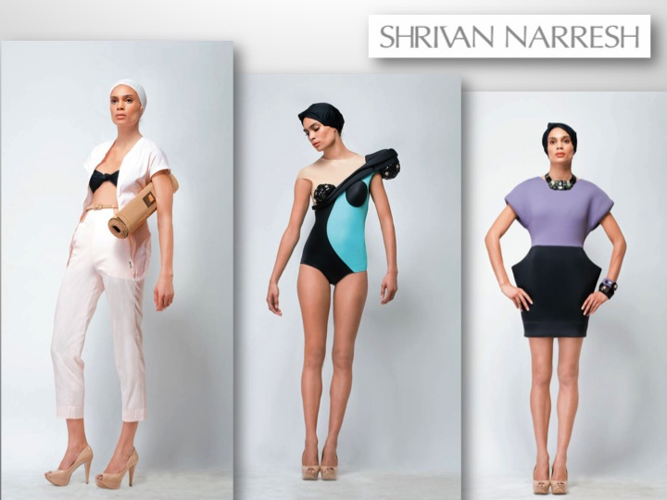

For additional information, please contact Odette Rodriguez at 212-334-6865, or email odette@leelany.com. LEELA, 580 Broadway, Suite 711 New York, NY 10012

